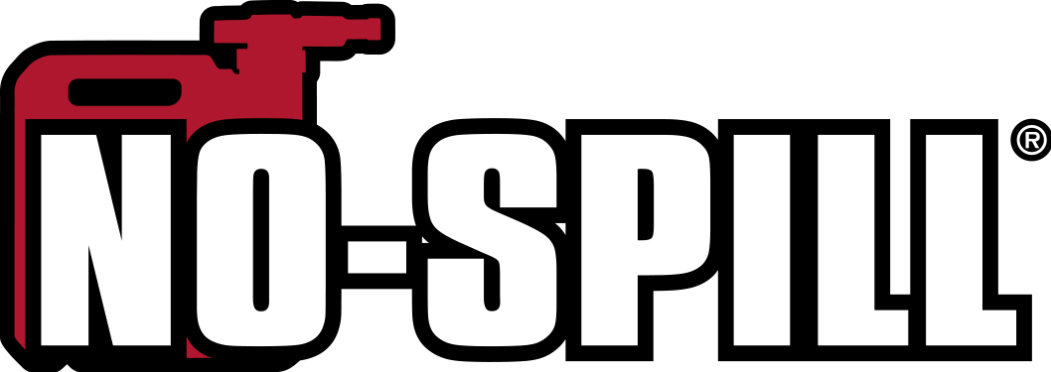
9808 Pflumm Road Lenexa, KS 66215
913.888.9200 -phone 913.492.8408 - fax

CPSIA GENERAL CERTIFICATE OF CONFORMITY
Issued by
No-Spill, Inc.

1. Products covered by this certificate:
No-Spill® Portable Fuel Container models:
1415 1¼ Gallon Gasoline Can
1405 2½ Gallon Gasoline Can
1450 5.0 Gallon Gasoline Can
1456 5.0 Gallon Kerosene Can
1457 5.0 Gallon Diesel Can
6415 1¼ Gallon Gasoline Can (Canada)
6405 2½ Gallon Gasoline Can (Canada)
6450 5.0 Gallon Gasoline Can (Canada)
6456 5.0 Gallon Kerosene Can (Canada)
6457 5.0 Gallon Diesel Can (Canada)

Easy Can® Portable Fuel Container models:
3415 1¼ Gallon Easy Can Gasoline Can
3405 2½ Gallon Easy Can Gasoline Can
3450 5.0 Gallon Easy Can Gasoline Can

2. CPSC product safety regulations to which this product is be certified:
H.R. 814 (llOth): Children’s Gasoline Burn Prevention Act. ASTM F2517-17. Section 9 of the CPSA (15 U.S.C. 2058)

3. Foreign or Domestic Manufacturer certifying compliance of the product:
No-Spill, Inc.
9808 Pflumm Rd
Lenexa, KS 66215

4. U.S. Importer, if applicable: N/A

5. Private Labeler, if applicable: N/A

6. Contact information for the individual(s) maintaining records of test results:
Tom Cray - Quality Control Manager – 913.888.9200 - info@nospill.com

7. Date and Place of final assembly: November 2010 to Present: Lenexa KS USA

8. Date and Place where this product was tested:
October 3, 2018 – Mississauga, Ontario L5N 6B9

9. Identification of third party laboratory on whose testing the certificate depends:
Cambridge Materials Testing Limited
6991 Millcreek Drive, Unit 13
Mississauga, Ontario L5N 6B9

created October 3, 2018 by No-Spill, Inc.

